Kathleen Qin

SUSA: Research and Publication

Fall 2017

The Evolution of Lyrics

**Lyrics, Then and Now**

From traditional, throwback songs like “Walking on Sunshine,” by Katrina & The Waves, to “Whistle,” by Flo Rida, musicians tend to be singing a lot more about sex, money, and drugs, rather than life stories, love, or…sunshine. Additionally, because of improved technology within the years, the majority of new music produced tend to have more bass, more energy, compared to some older songs, which may have more acoustic. Despite the increase in innovation, music also seems to be less organic than that in the past. It’s not that all the music produced today are bland or seem artificial, but more songs today seem more repetitive and less “organic.”

To give a visual on the difference between lyrics then and now, below are some visuals from the *International Business Times*:

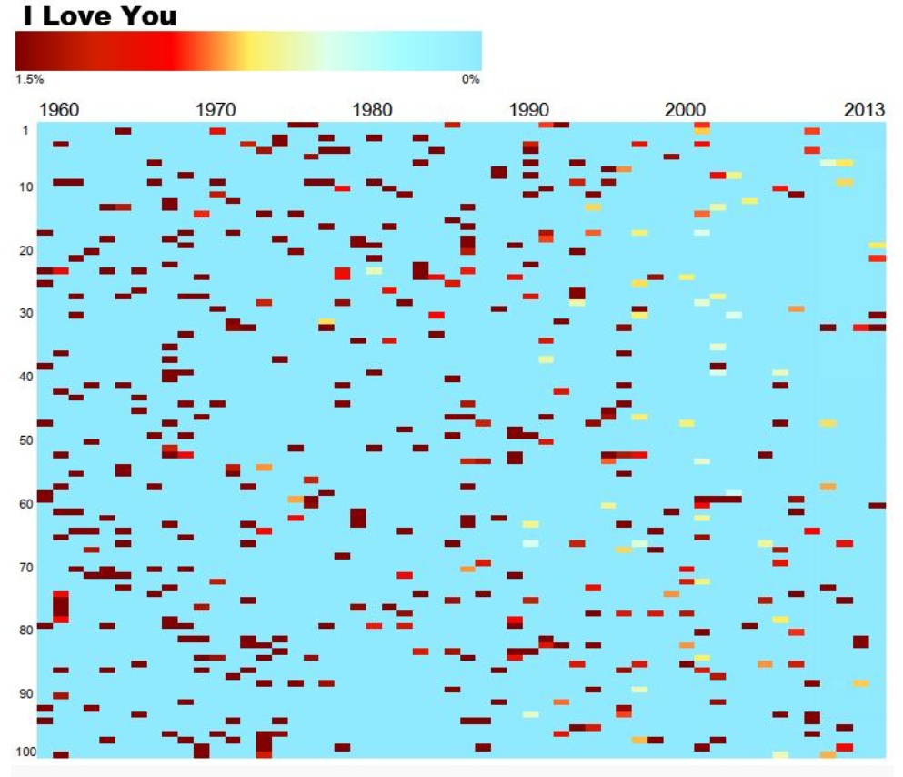*The x-axis is the year of the song's release and the y-axis is the song's popularity according. With each cell representing a song, the more red the cell is, the more often that particular word appears in the song. In other words, the higher the percent, the darker the shade of red.*

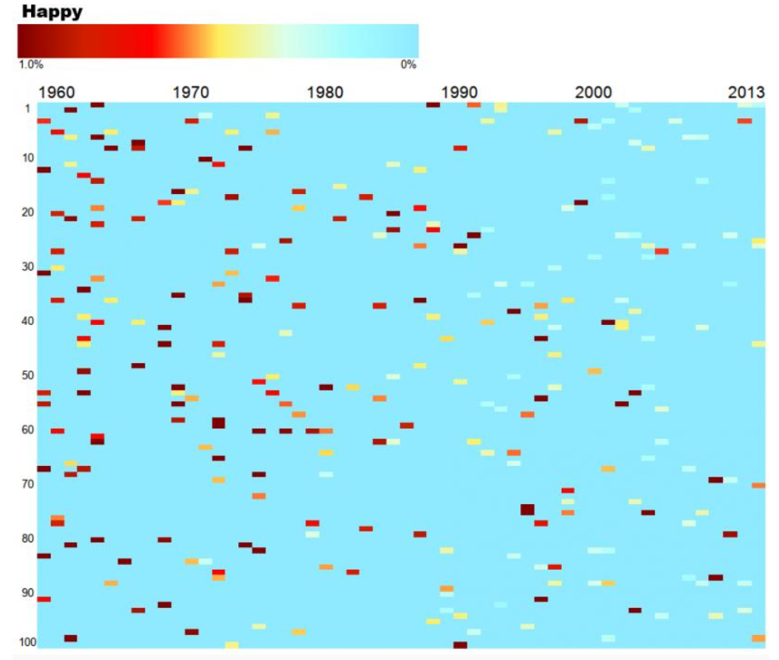

Here, words like “I love you” and “happy” were more popular in the past while words like “weed” and “body” pop up more often today.

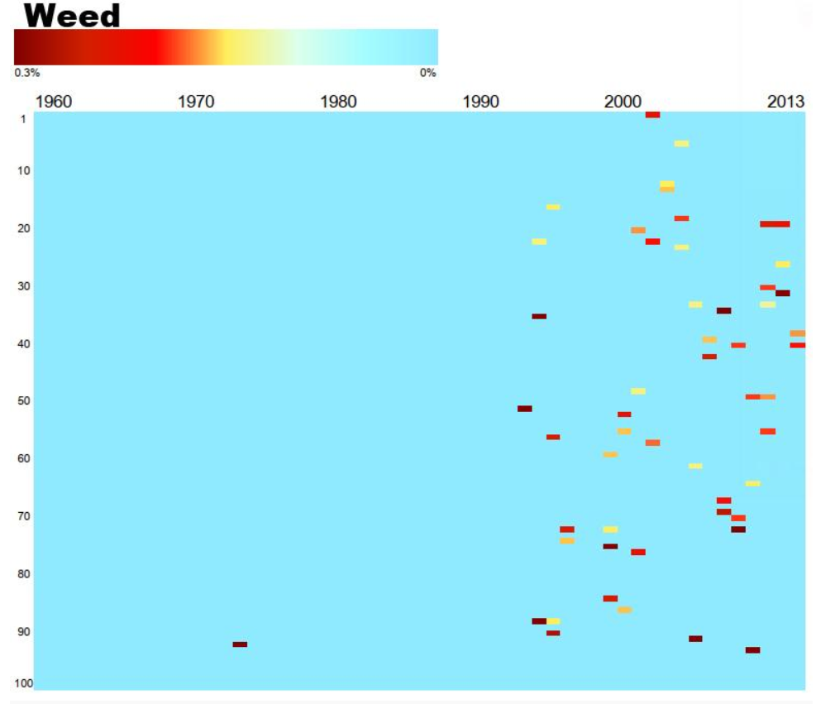

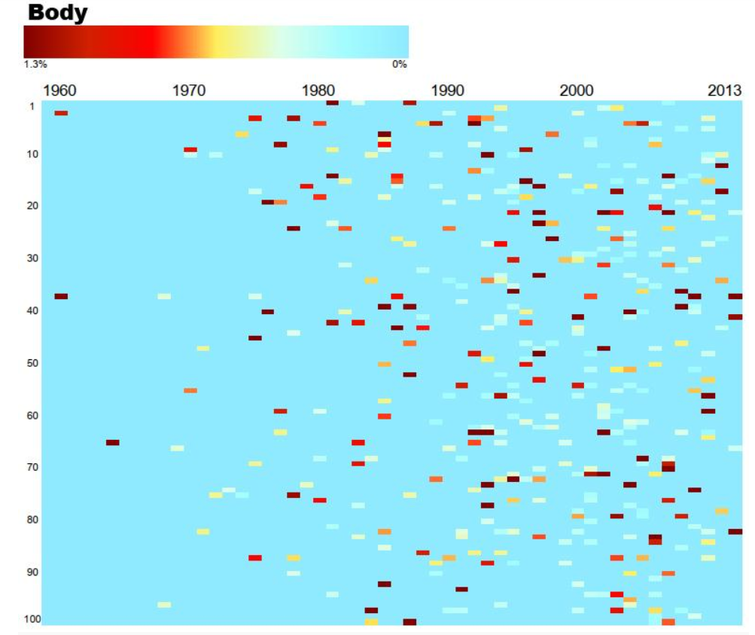

**How it Started**

For my Research and Publication project, I will also be looking into the trends of music lyrics. I chose this topic because music is something that most people, if not everyone, can relate to. It moves people of all cultures, in a way that can trigger so much emotion and vast experiences. Music is something that everyone can share, even when individuals have completely different tastes/preferences. I think most people probably don’t realizes the gradual changes in newly released songs throughout the years. Individual music tastes can evolve as well without one even noticing. This presentation is aimed at illustrating how music, specifically the lyrics, have evolved throughout the decades.

**Let’s Get To It**

This project can be summed up into three main parts: finding the data, cleaning the data, making a visual. Ideally, I would probably have went to Genius to get as much data as possible consisting of music lyrics, artists, song names, etc. and manipulating that for this project. However, because I have no background programming experience, I found a data set of the top 100 Billboard songs spanning 50 years.

My dataset consists of the top 100 songs from *Billboard* charts from 1965 to 2015. This dataset was then narrowed down to the top 300 words per decade and the frequencies for each of the 300 words were found. For example, below is an image of some of the frequencies from the 1960’s.

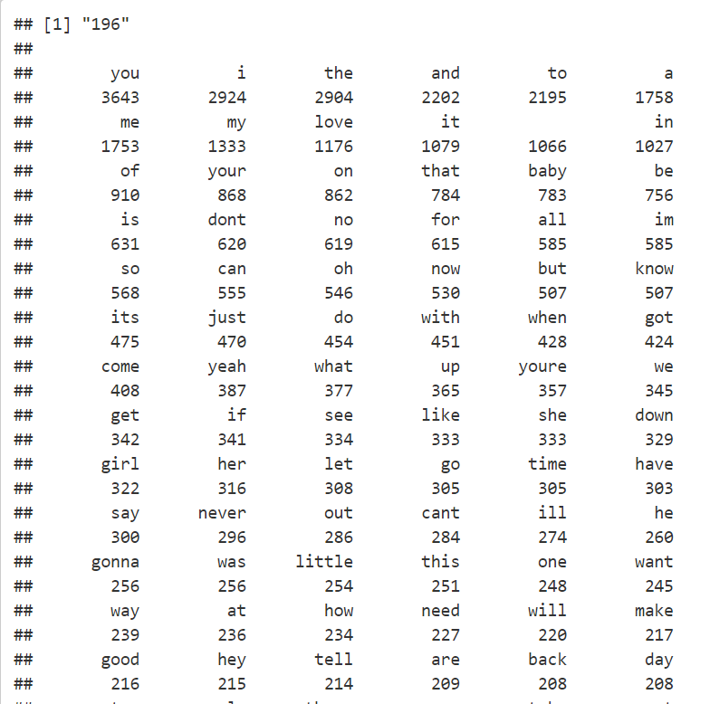

To help better visualize the trend of lyrics, below is a frequency plot of 30 words that will reveal how certain words grow and fall in popularity. The horizontal axis denotes the decade and the vertical axis represents frequencies. The individual words are color-coded accordingly.

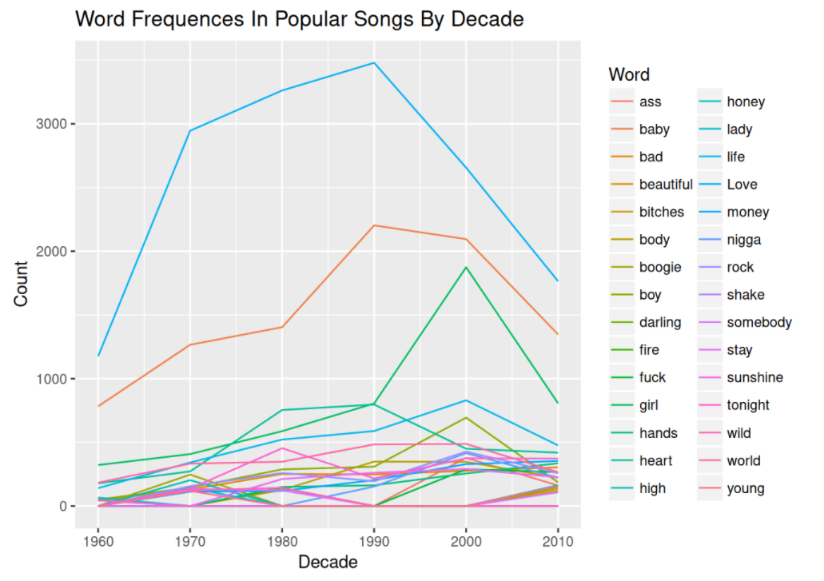

As seen, words like “boogie” and “sunshine” have gone outdated while words like “love” and “baby” are more stable in popularity. This is probably because words like “love” and “baby” are not dependent on any current trends or generations. These words are used more universally, whereas the word “boogie” would be more popular at a specific time because of a trending song, dance, and/or movie.

The frequencies found also showed that words gradually became more “inappropriate.” For example, in 1990’s, we have “sweet,” “lover,” and “wild” as some of the most popular words in that decade, compared to 2010’s where some of the most popular words are “money,” “bitches,” and “bottoms.”

**Coulda…Shoulda…Woulda**

Some issues I stumped upon during this project was the data visualization part. I realize that the graphic may have a lot going on, however I thought that having less words wouldn’t show the trends as well, and splitting the same graph up into different graphs would be messier and the words would be harder to compare.

Also, with more programming experience, I probably would have tried to weight words and categorize them as either “positive” or “negative” and then see if certain decades had songs that were more happy or sad. If any trends came up, these could them be correlated with possible events that were happening during those years.

Another idea would be to see if particular artists whose songs are in the top 100 early on, tend to have more songs in the top 100 in later decades as well. If they do, do their lyrics evolve over the years as well?

**TaDa**

Through this project, there’s clearly some evidence that the word choice in songs today are quite different from those at least 30 years ago. Some reasons could be because of new slang introduced, changes in culture/trends, or perhaps a rising star introducing something new in the field.

Overall, it’s been a fun experience looking into current and past lyrics and finding a pattern within them. Not only did I get exposed to some programming but I also had the opportunity to investigate in a topic that I had a curiosity about, and eventually find an answer for myself.

**Thanks!**

Thank you to Winne and Isaac, who have supported me along the way, and my fellow R&P friends for giving me advice and recommendations.